2020.08.23

WI DHS CARES Act Provider Payments (CAPP) Program Paid To Date

LTC COVID-19 Stakeholders,

I was not able to attend last week’s meeting but I know there was a question about payments made under the Department’s CARES Act Provider Payments (CAPP) program. A summary of payments made to date for Phase 1 (based on applications submitted by June 30th) is below. These amounts reflect both the initial up-front payments as well as subsequent larger payments that the Department is distributing to providers this week.

Please note that additional Phase 1 applications are going through the review process and the Department will continue to make payments as those Department reviews are completed.

The CAPP payment applications will re-open in September. All available information on the September application can be found here: <https://www.dhs.wisconsin.gov/covid-19/dpp.htm>.

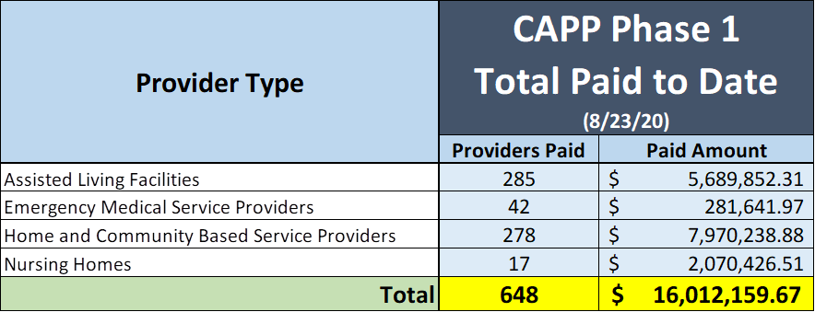

Thanks,

Ben

Ben Nerad

Director, Bureau of Rate Setting

Division of Medicaid Services

Wisconsin Department of Health Services

608-720-9031 | [benjamin.nerad@wi.gov](mailto:benjamin.nerad@wi.gov)